|  |
| --- |
| Allen Institute |
| PROTOCOL: Behavioral Annotation |
| Methods to Quantify Mouse Behavior |

|  |
| --- |
| Mahdi Ramadan  6-24-2016 |

# Running Recons Protocol

Quantitatively assessing behavior is a major challenge due to the subjective nature of human decision and observation. This protocol will provide specific guidelines and criteria to minimize this variance.

## The Purpose

Understanding behavioral constructs is a crucial portion of the Allen Observatory initiative, which aims to understand the neural correlates of visually induced decisions and behavior. The first step to understanding such a correlation is to have a clear annotation and labeling of behavior.

## Background

Each mouse experiment is set-up with a two-photon microscope to image neural fluorescence, an eye tracking camera, and a behavioral camera capturing the full body of the mouse. We will be studying and analyzing the behavioral camera. Each experiment/video is approximately one hour long.

## Process Overview

To annotate the videos, we will be using a slightly modified version of the original behavioral video, but with the added convenience of a frame counter displayed on the video itself, as well as the speeding up of the video (two times speed).

We will be using an ( …) document to annotation and record behavioral states. (..) is being used for its ease of use, universality, and ease of import into coding languages such as python for further analysis.

As the video is being watched, behavioral form and actions will be recorded according to the start and end frames displayed on the video. While the presence of individual actions might be discrete events in time, body form should be a continuous temporal variable. Specific direction can be found below.

# Initial Setup

You only need to do initial setup once on the machine you plan to use.

1. A list of behavioral videos to annotate can be found in document (….. .xlx), which can be found (..). It is crucial to stick to this document, as we need to keep track of training data in any future analysis.
2. Download (beh_annotation.py) and the behavioral video you intend to annotate.
3. In (beh_annotation.py), set exp_folder equal to the string path of the folder in which your video is in. For example, my behavioral video is in the directory “/Users/mahdiramadan/Documents/Allen_Institute/videos”, and is specifically in the folder videos.
4. …..
5. How to open annotation program
6. Keep track of progress on a live document
7. How to annotate and where to input
8. …

# Decision Tree

Mouse behavior is dissected along various dimensions.

The first split is decided relative to the motion state of the mouse: Moving, stationary or flailing

**Moving:**

1. The criteria for moving are:
   1. The wheel on which the mouse is positioned on is rotating for a minimum of two seconds.
   2. The second criteria is the lack of contact between the wheel and the mouse underbelly. As you can imagine, if the mouse is to move, it must lift up its body off the wheel. Lack of contact can be easily detected when the visual screen in the background can now be seen as a result of the lifting of the under belly. See below for examples
   3. Note: If ever in doubt of wheel movement, validate with the wheel velocity data available in stimulus_behavior.py (StimulusBehavior.raw_mouse_wheel)

|  |  |
| --- | --- |
|  |  |
| Stationary, underbelly on wheel, can’t see background | Moving, underbelly off wheel, can see background |

**Running and Walking:**

If the mouse is moving, the speed at which the movement is occurring with is categorized into a running or walking motion. The criteria for running are:

* + - 1. Running motion can be determined by looking at the hind legs of the mouse. If the mouse hind legs are moving fast enough to cause motion blur (due to the limited frame rate of the camera), should meet criteria for running. Movement should last at least two seconds.
      2. As opposed to walking, full speed running will induce an elevated and straight body form, with hind legs fully extended. Walking movement is characterized by a more curved body shape and slower feet movement.
      3. Note: movement speed could also be validated with the wheel rotation data found in stimulus_behavior.py (StimulusBehavior.raw_mouse_wheel)

|  |  |
| --- | --- |
|  |  |
| Mouse running behavior. Notice the motion blur on the hind legs. Hind legs are fully extended and body is parallel to the disk. Body is straight and legs are fully extended back. | Mouse walking behavior. There is little motion blur, body shape is curved. (example mouse ID: 525145790, minute 10) |

**Stationary:**

**Grooming:**

1. When relaxed and comfortable, a mouse might start grooming itself. Grooming is characterized by repeated gentle strokes of the face and mouth with their front limbs. Criteria is at least two seconds of repeated grooming motions (as described above).

|  |  |
| --- | --- |
|  |  |
| Mouse grooming behavior in both panels. | Mouse ID: 520645919 minute: 32-34 |

**Mouth Chattering**:

1. It is unclear as of yet whether chattering in the mouth is grooming (relaxed) or a sign of stress in the mouse. Nevertheless, it will be invaluable to note. The criteria for mouth chattering is at least two seconds of rapid repetitive mouth (and sometimes nose) movements. To an individual this behavior might look very similar to chattering. An example of this can be found in the behavior video of mouse ID: 520759473, time 22:50 – 23:10. Link is: \\titan\cns\neuralcoding\prod9\specimen_511977844\ophys_experiment_520759473\

**Startle Response:**

1. At times, the mouse might exhibit a startle response. A startle response is characterized by a sudden change in body form while the mouse is **NOT** moving (stationary). The criteria are as follow:
   1. A sudden lifting of the midsection upward off of the wheel, revealing the background behind. Usually, the elevated position is returned to baseline quickly (under two seconds). If the mouse starts **moving** within one second of the response, the behavior should **NOT** be annotated as a startle response. Upward startle response is apparent in the first ten seconds of the behavior video for mouse ID: 520759473. Link:

\\titan\cns\neuralcoding\prod9\specimen_511977844\ophys_experiment_520759473

* 1. A sudden contraction or extension of body shape/form accompanied by an observable change in body length. If the mouse starts **moving** within one second of the response, the behavior should **NOT** be annotated as a startle response.
  2. **Note:**
     1. The startle response should be annotated from a change in states, not the absolute configuration of the mouse. We are looking for a **change** in form.

|  |  |
| --- | --- |
|  |  |
| Mouse is in an extended form. | Mouse is in a contracted form. Mouse ID: 520645919, time 14:30-14:40 |

**Flailing:**

Due to painful positioning or induced panic, the mouse might partake in flailing behavior. Flailing behavior, or struggling, is characterized by several criteria:

1. Frantic repositioning of limbs, often resembling a reaching/grabbing motion to the side or to the front of the mouse. Limb motion resembles tapping/shaking.
2. Displayed attempts of escape behavior, such as:
   1. Twisted and strained body position, at times accompanied by a frantic and quick repositioning of the body into awkward forms or from side to side.
   2. Mouse pushing on the wheel platform with fore and hind limbs **without** inducing any directional and consistent movement (wheel is usually rotated back and forth quickly during the struggle). Bouts of forward and backward movement.
   3. Grasping edge of wheel with paws.
   4. Unnatural gait or walking
3. Flailing behavior as an example can be seen in the behavioral video of mouse ID: 511977705, on and off between minutes 1:00 to 6:00, link:

\\titan\cns\neuralcoding\prod6\specimen_503292436\ophys_experiment_511977705\

|  |  |
| --- | --- |
|  |  |
| Mouse is grasping wheel with over extended limbs, body form is over-stretched. | Mouse is pushing on wheel with forelimbs, back and body arched to the side in an unnatural positon. No directional and consistent movement. |

**Global Traits:**

Along with keeping track of motion and their respective features, it is important to note two global traits that are indifferent to the state of motion. The two traits are tail position and lower trunk flexion.

**Tail Form:**

1. Tail form is also important to consider when observing moving behavior. The tail could be two states: the tail could either be relaxed or could be tense. The tail can tense in several dimensional axis, including up or to the sides, or both.
2. The criteria for a tense tail are as follow:
   1. The tail base is elevated at an angle greater than zero relative to the central body axis
   2. Over half of the tail is elevated off the wheel
   3. The tail is turned to the side beyond a 45 degree angle relative to the plane of the central body axis
3. Otherwise, the tail is relaxed (easy to intuitively sense if the tail is relaxed as well!)

|  |  |  |
| --- | --- | --- |
|  | camera |  |
| Tail elevated up an angle greater than zero relative to the central body axis. Mouse ID: 524644261 | Tail tensed to the side, beyond a 45 degree angle relative to the plane of the central body axis. The schematic below shows a bird’s eye view of the set-up, with the a red line describing the central body plan of the orange mouse, and the second angled red line representing the cutoff 45 degrees to be considered a sideways tensed tail. Mouse ID: 524644261 | Tail is relaxed. |

**Lower trunk:**

1. It is important to note the presence of lower trunk flexion. The lower trunk can either be naturally lifted or forcibly depressed though flexion. Lower trunk depression is characterized by a **curved/arched central body axis**, and can be accompanied by a “crawling/dragging” motion in the hind legs and bottom. At times the mouse will be stationary with its midsection and front shoulders lifted up, but will have a curved central body axis due to a depressed lower trunk.
2. Note that when the lower trunk is **not** depressed, the central body axis of a moving or stationary mouse is relatively straight and **parallel** to the wheel.

|  |  |
| --- | --- |
|  |  |
| Mouse with elevated lower trunk. Central body axis is parallel to wheel. | Mouse with depressed lower trunk. Central body axis is curved. (Example Mouse Id: 524883096) |

# Tree Visualization

Here is a visual of the behavior decision tree.

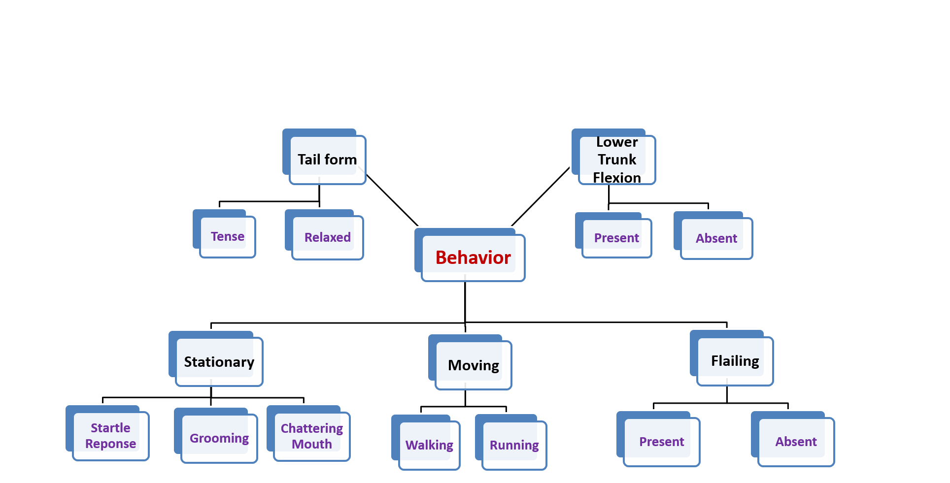

# Notes

The features described above have been carefully studied and chosen for specific reasons, as discussed below.

* Why moving versus stationary? One of the more apparent behavioral paradigms observed in the behavioral videos is the presence or lack thereof of movement. In fact, the experiments themselves were designed to explore and study the decision making processes of mice, such as the decision to move. Thus, it made sense to me that the first split would be according to movement behavior, both for its ease of classification and overarching scope.
* Why study running versus walking? One of the few validation data sets we have of the mouse’s behavior is raw rotation data from the wheel that can yield the mouse’s velocity. For testing any future machine learning models, a good first step would be to use stationary vs. walking vs. running annotated data to train the computer vision model, and then be able to validate these classification according to the raw velocity data.
* Why study tail and lower trunk form? From various videos, I noticed that the positioning of the tail along with the lower trunk were good indicators of different states of alertness and/or stress, as validated by raw eye tracking videos (presence of white foam/film)
* Why study mouth chattering? One of the features we as a group would like to study is whisker movement, which is unfortunately very difficult to measure due to the thin geometry and coloring of the whiskers themselves. But what we can see is the mouth and cheek movements responsible for the whisker movement, and we hope this feature will be a good proxy measure.
* Why study grooming? Grooming is a reliable measure of mouse comfort and relaxation, and so it is helpful in that it can be a control data set for stress data sets.
* Why study startle responses? The paper “Visual recognition memory, manifested as long-term habituation, requires synaptic plasticity in V1” demonstrates the close relationship between the startle response, noted as vidget in the paper, and V1 stimulus induced activity to novel stimuli.
* Why not study ear position? Due to the anchoring of the mouse’s head to the microscope, the mouse’s ears are constrained in their movement. Thus, the positioning of the ear is caused more so by the microscope than behavioral motives.
* Why have is a body extension or contraction considered a startle response? As mentioned in the paper “Visual recognition memory, manifested as long-term habituation, requires synaptic plasticity in V1”, a vidget was detected as a change in pressure upon the platform which the mouse is standing on. A sudden change in posture will also induce a similar change in pressure. The paper does not differentiate between a postural change and a sudden jump, and thus we should consider both to remain consist with their methods.
* Why study flailing? Flailing is one of the most indicative behaviors of distress in a mouse, and would be a great feature for detecting stress levels during an experitment.
* Why use a two second behavior threshold? The paper “Visual recognition memory, manifested as long-term habituation, requires synaptic plasticity in V1” demonstrates that vidget behavior reaches a maximum measure (in this case pressure) at two seconds, and remains distinguished for at least five seconds. Any behavior lasting less than two seconds can be considered “less than optimal/did not reach peak effectiveness”. See figure below:

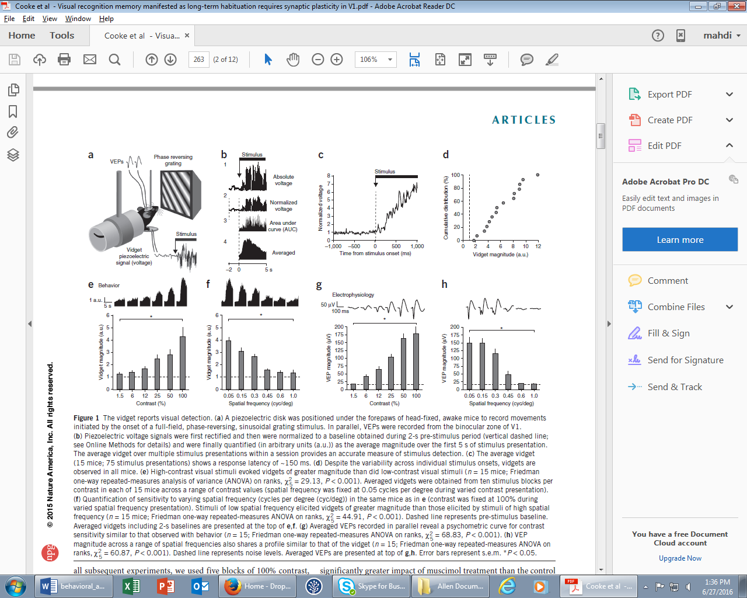

**2.0 sec**